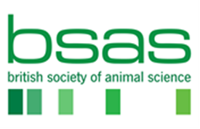

Nomination for the Sir John Hammond Award
Please return to Maggie Mitchell by 1st March 2024
Nominee ( please provide details of person you are nominating for this Award)
Title

First Name

Surname

Organisation

Role & Responsibilities:

Email

Nominators (please provide details of those proposing the above nominee for the Award)
Note: This award is based on nominations, please note that self-nominations and nominations from members of the judging panel will not be considered. A nomination needs to be supported by two members of either BSAS or BCBC.

Proposer
Title
First Name

Surname

Organisation |  | Please state if BSAS or BCBC Member
Email

Seconder
Title
First Name

Surname

Organisation |  | Please state if BSAS or BCBC Member
Email

Please provide key examples of the nominated candidate’s significant contribution to the United Kingdom and or Republic of Ireland through research, teaching, knowledge exchange, breeding, farming, industry or affiliated professions. Candidates do not necessarily have to have excelled in all of the areas outlined. Further information may be required for short-listed nominees.

Introduction (please include general information about the Nominee)
Max 100 words

Contribution (please outline the nominee’s significant contribution to the industry and/or animal science)

Impact (what is the current or future impact / benefit to the sector of the nominee’s work)

Career Overview (please outline the nominee’s career to date)

Summary (please provide a short summary as to why you are proposing the nominee for the Award)
Max 100 words

Date

